1. Create user with name Techie and provide sudo access to user  
   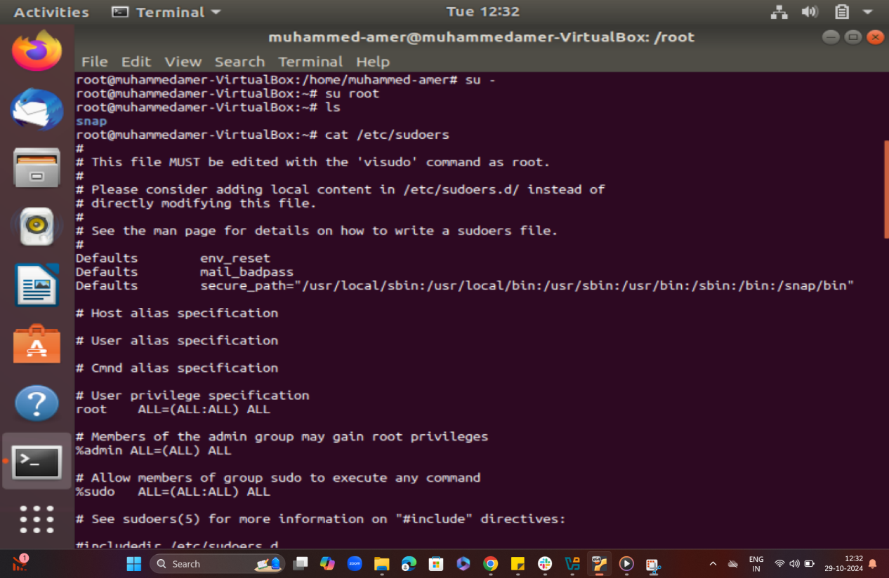  
     
   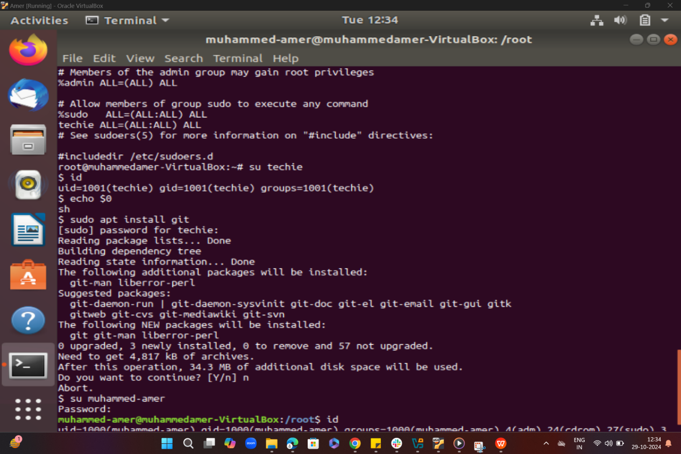  
     
     
     
     
     
     
     
     
   2) Navigate to the home directory  
   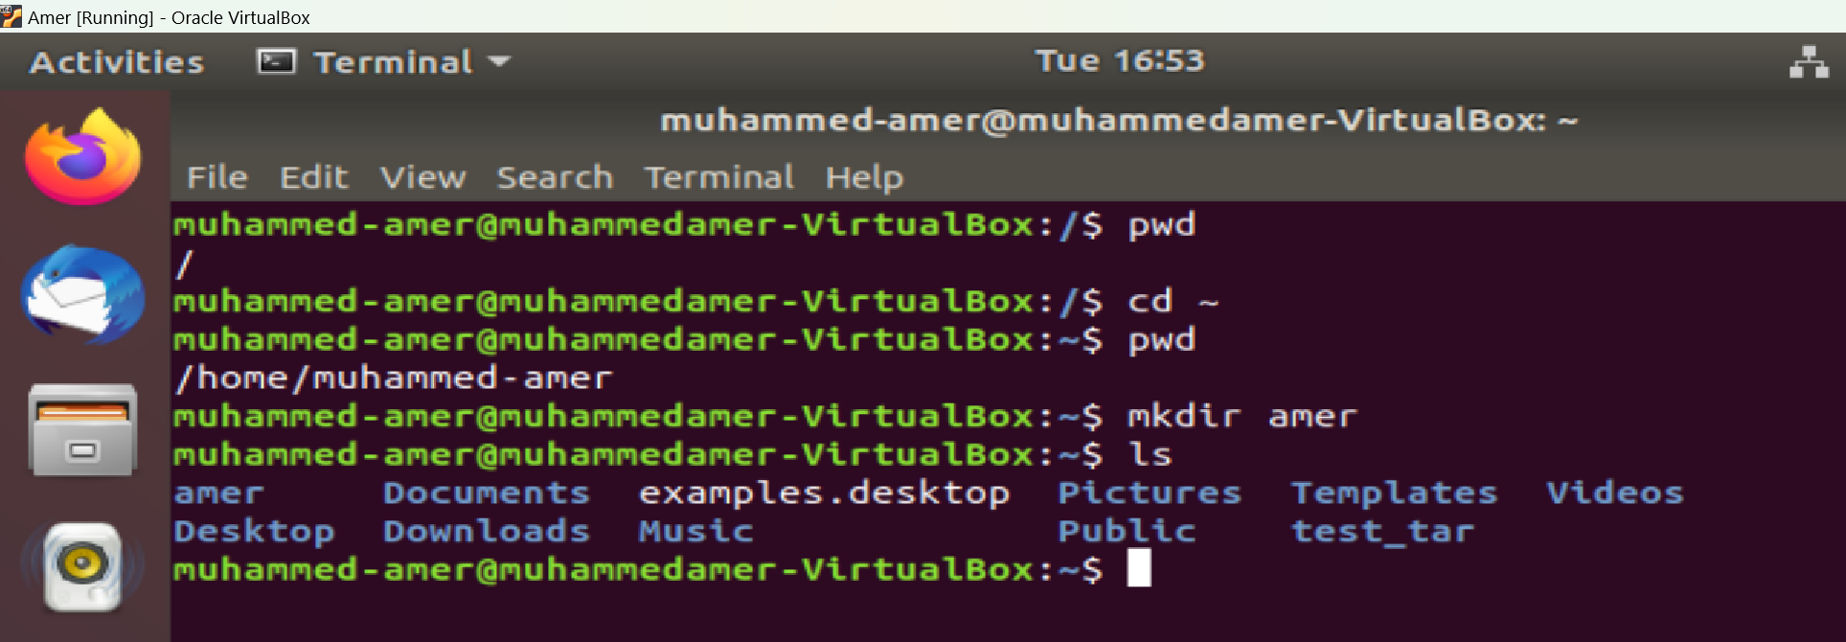

3) Create a new directory

  
  
  
4) List the contents of a directory

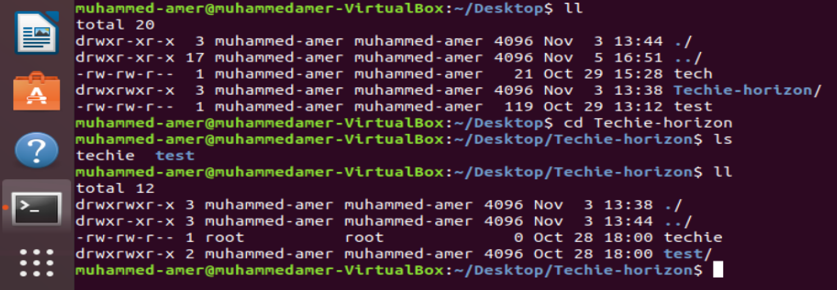  
  
  
5) Change the current directory

30)Print specific columns from a delimited file.  
  
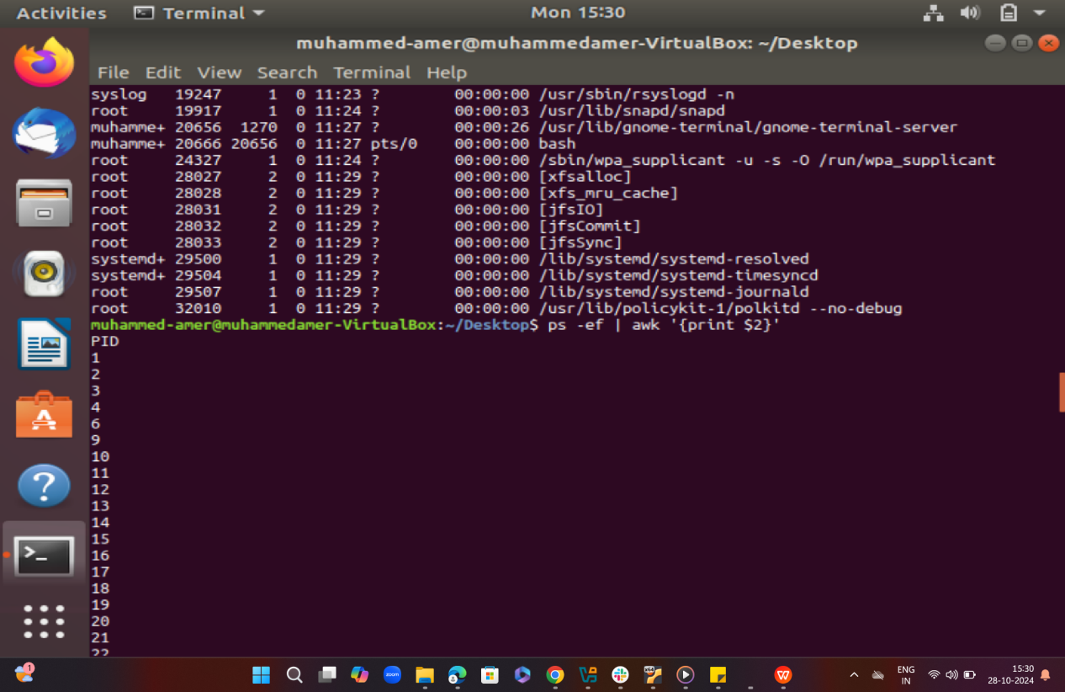  
  
  
  
  
37) Substitute text in a file using search and replace

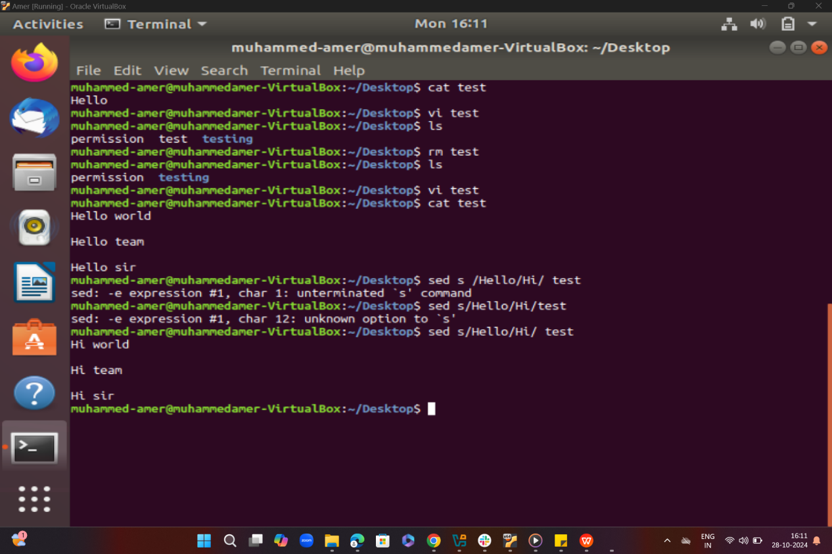  
  
  
  
  
38) Delete specific lines based on a pattern or line number.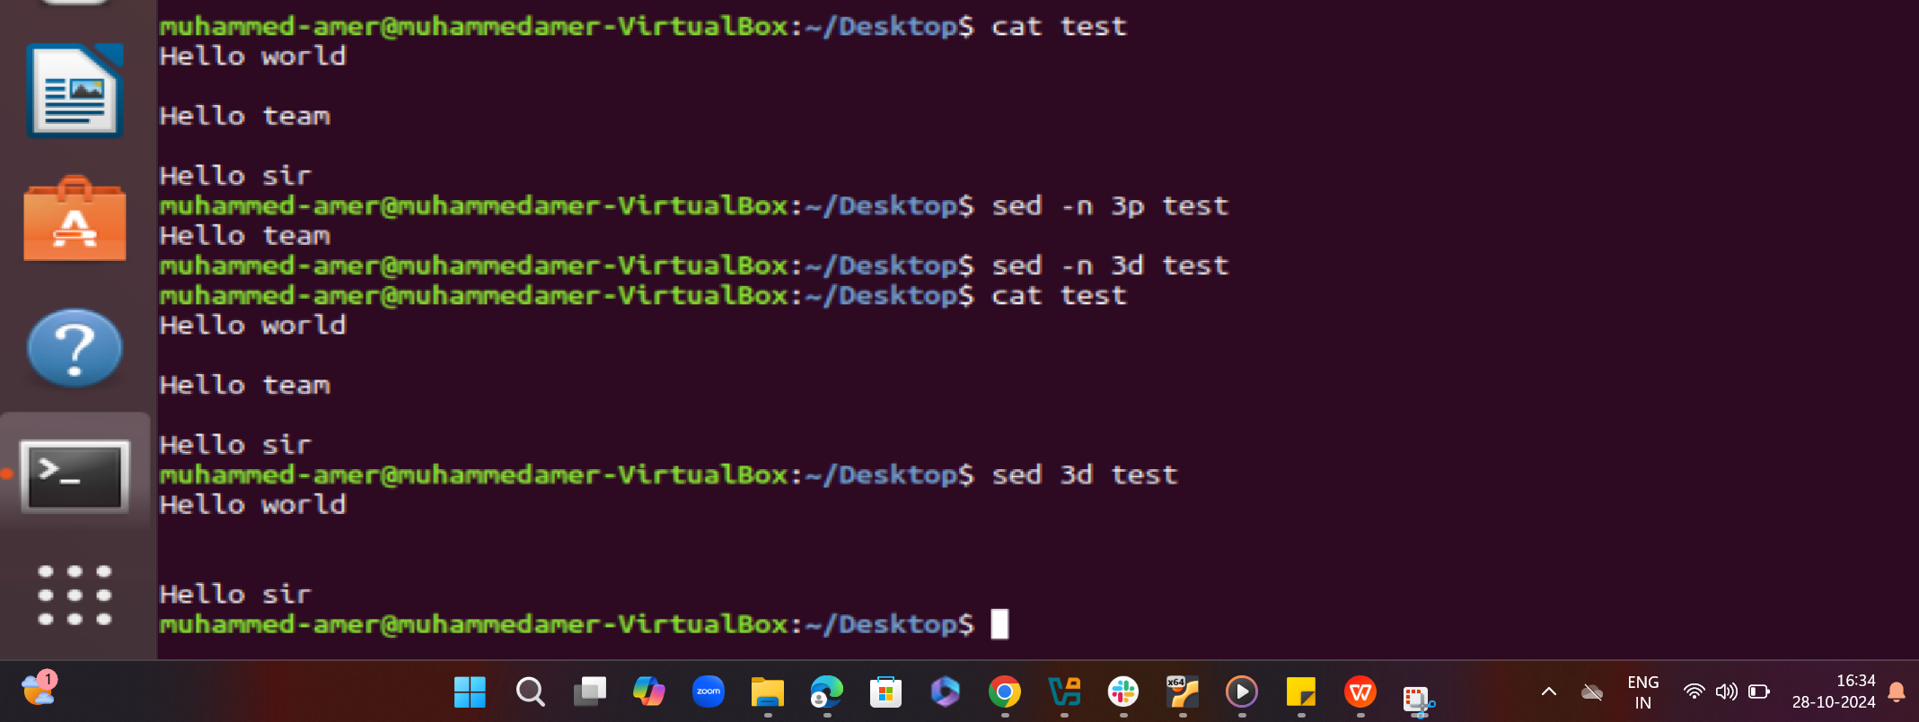  
  
  
  
  
39) Append or insert text before or after a specific pattern or line  
  
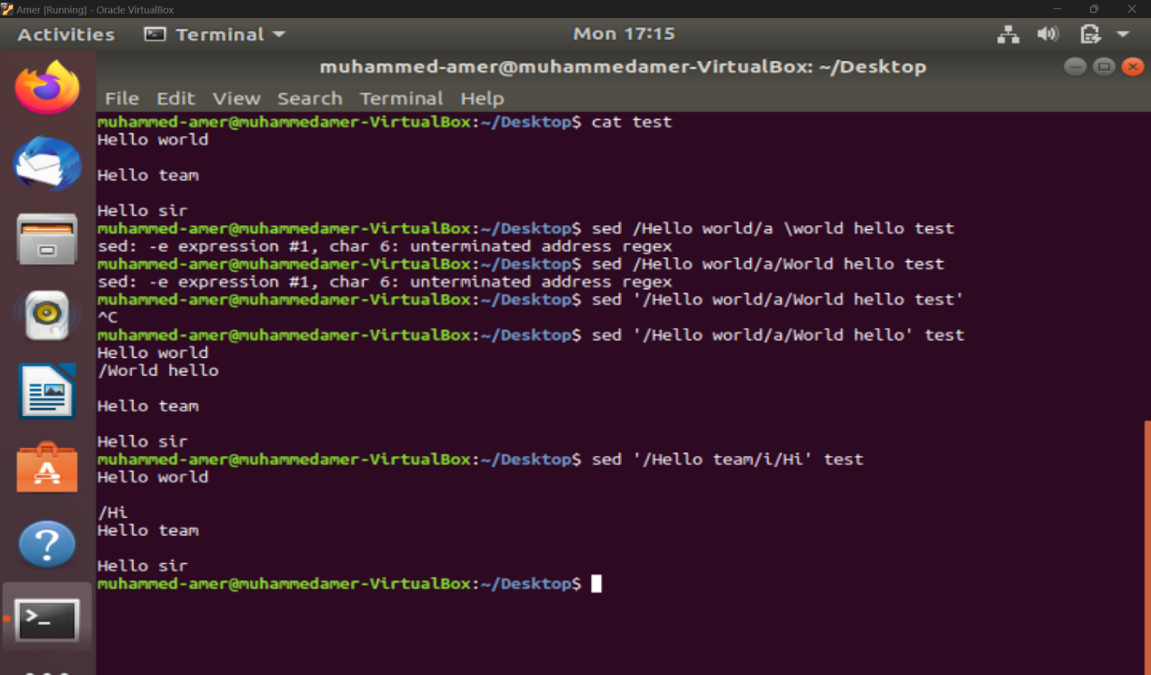

1. Print only specific lines from a file.  
     
     
     
     
     
     
   23) Create and manage user groups.  
   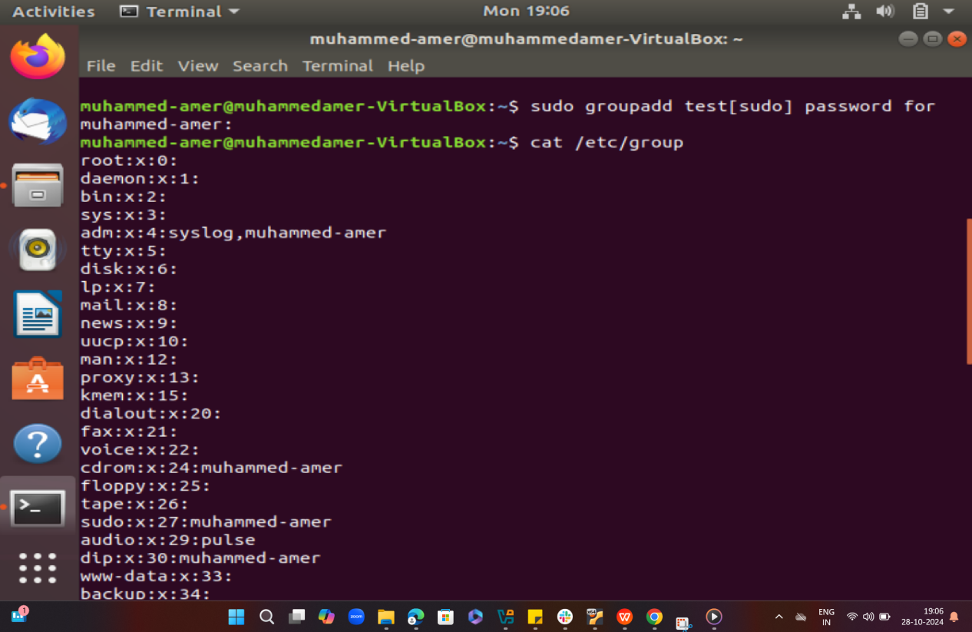  
     
   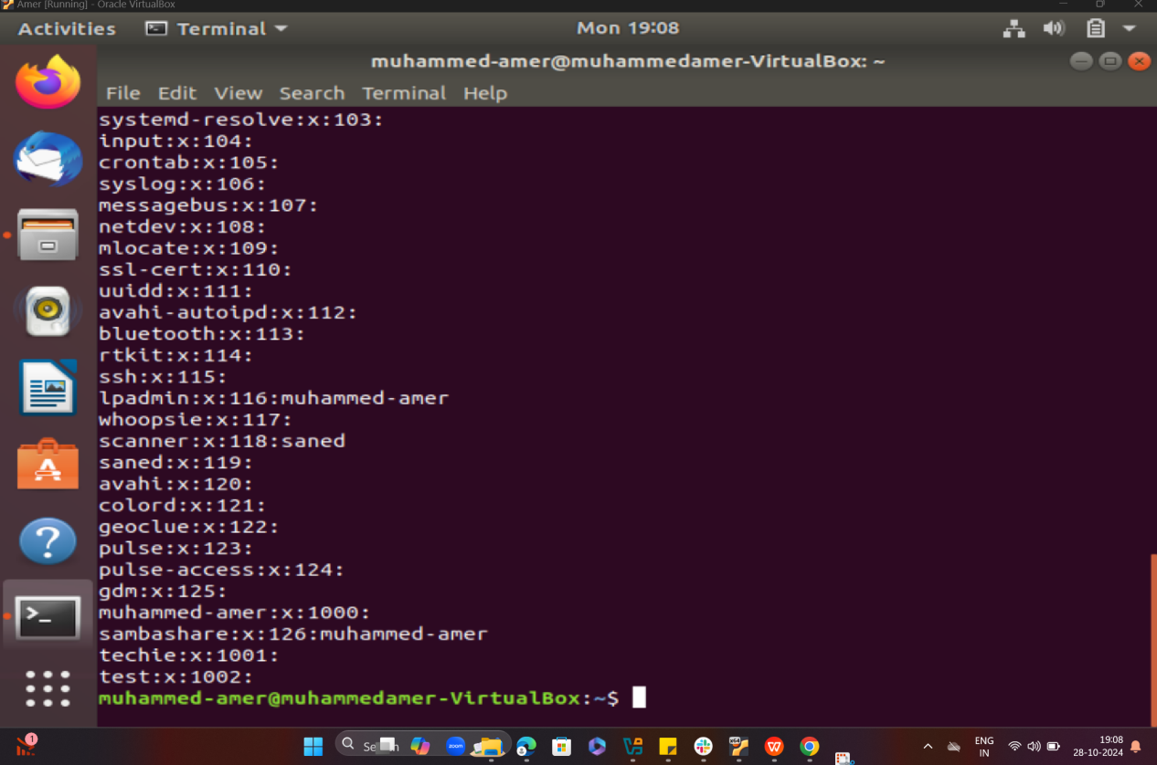  
     
   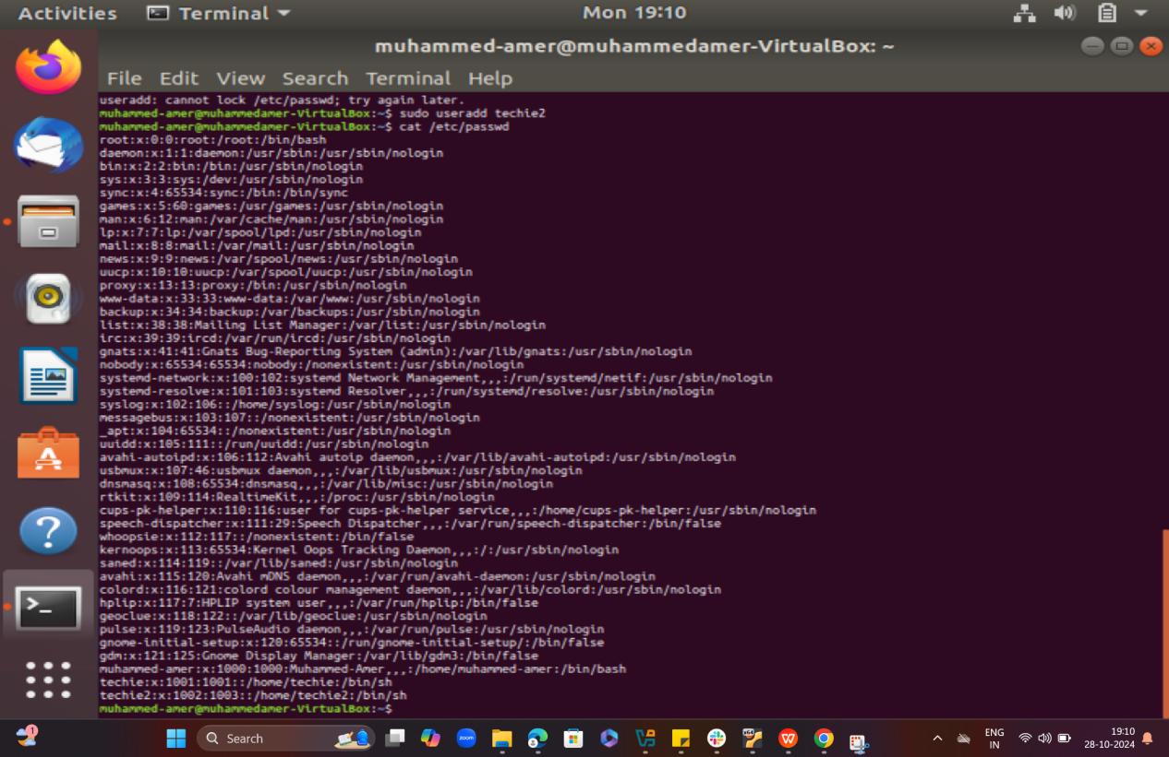
2. Monitor log files using tail or grep  
   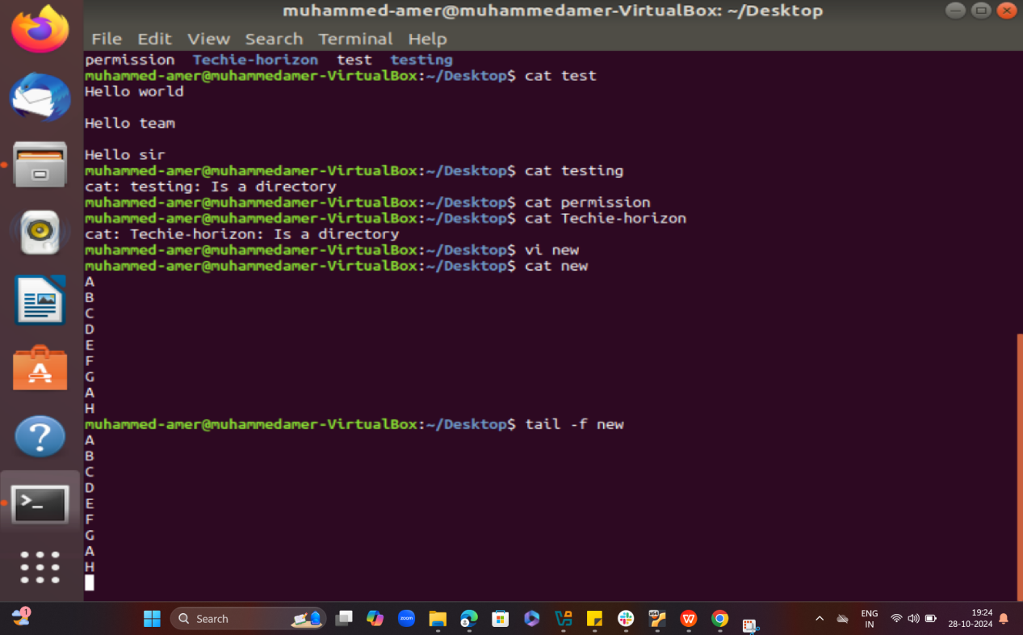  
     
     
   31) Filter and print lines based on a specific pattern or condition  
   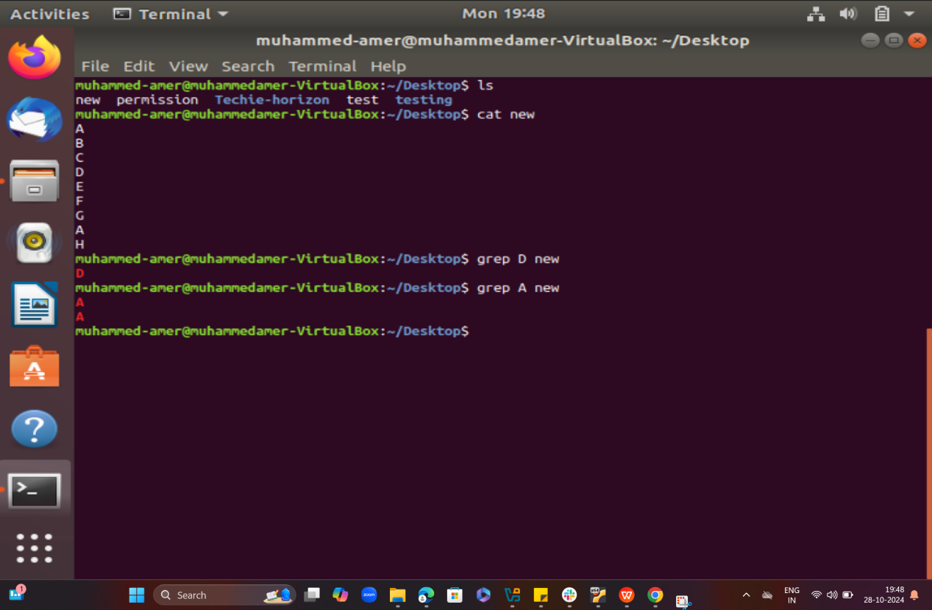  
     
     
     
     
     
   34) Count the occurrences of a specific pattern in a file  
   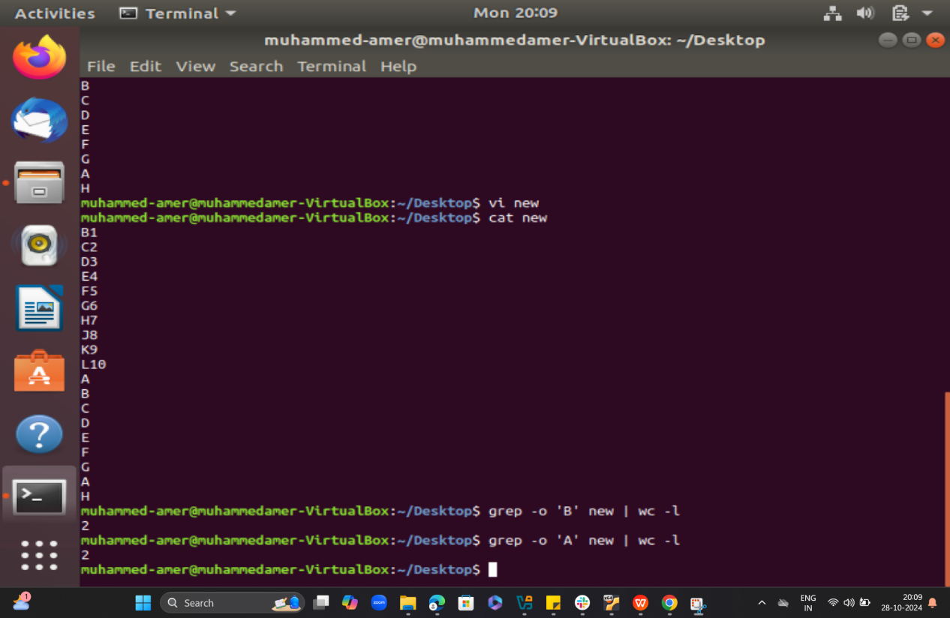  
     
     
     
     
     
     
   36) Merge multiple files based on a common field or column  
   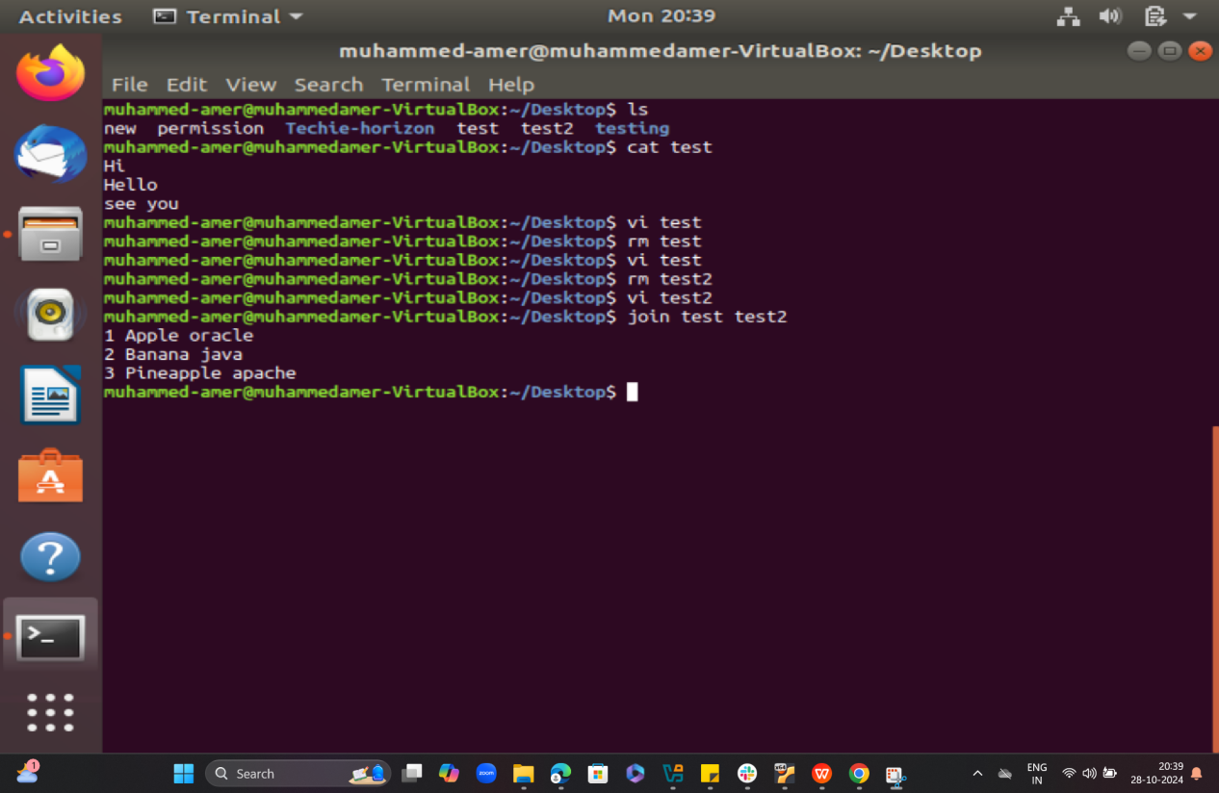
3. Create a symbolic link  
   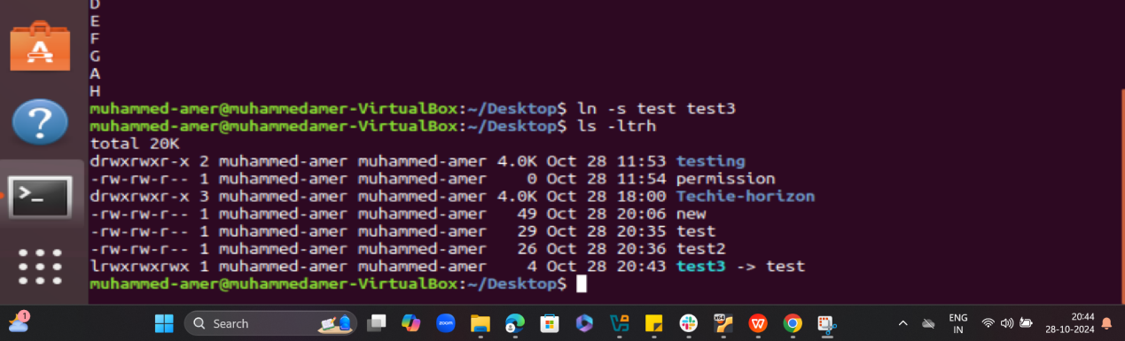  
     
     
     
     
     
     
     
     
     
     
     
     
   35) Sort lines based on a specific field or column.   
   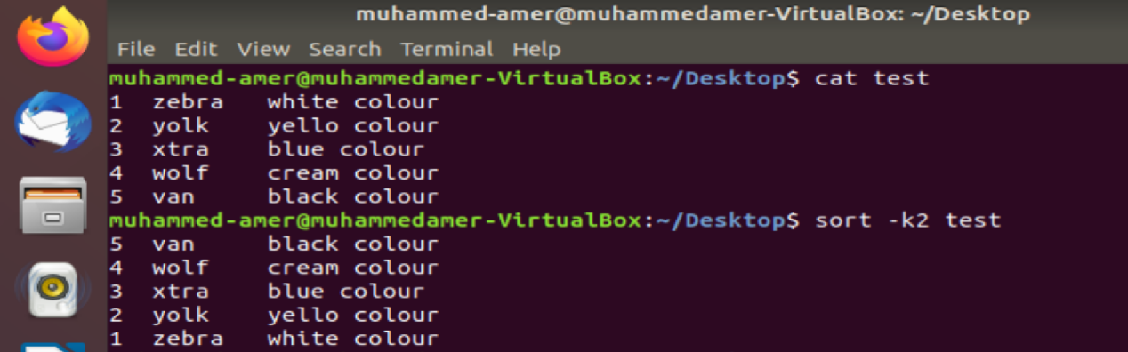

24) Set up SSH password less authentication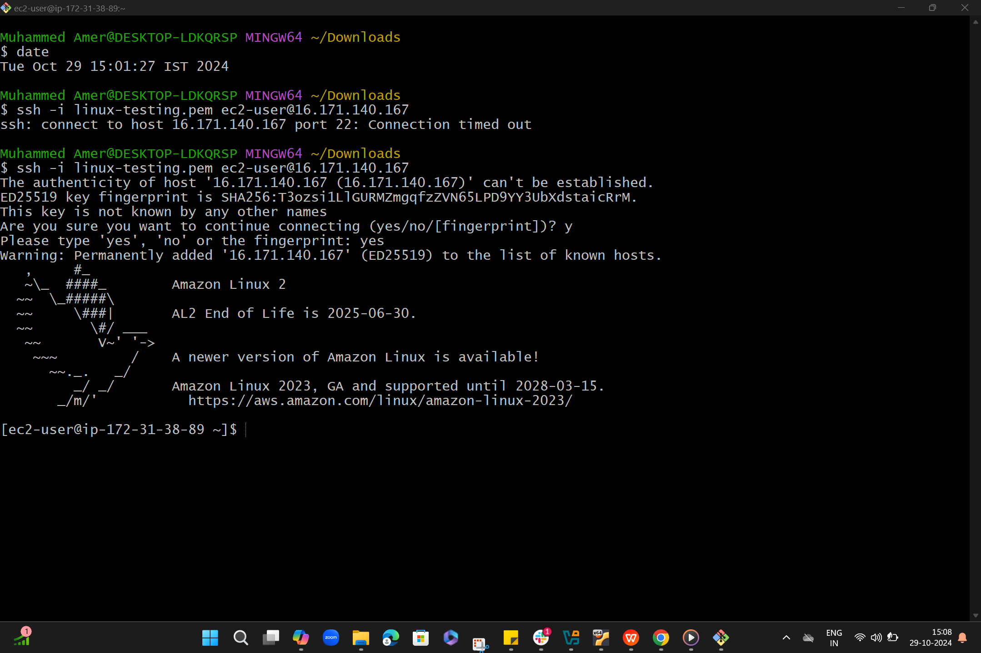  
  
  
  
  
  
32) Calculate and print the average, sum, or other statistics of a column.  
